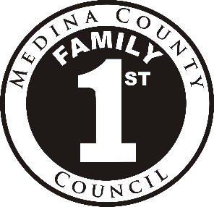
Medina County Family First Council
2017 Membership Application

Return before September 30, 2015 to:
Sharon Tahajod. PO Box 167, Medina, OH 44258
Or sharont20@ohio.net

You can join a team that puts families first in Medina County. The Medina County Family First Council is a group of community leaders and residents working together to improve services for families.

The Family First Council invites residents, including public officials, community leaders and parents, to join the group for three-year commitments. Members strive to boost the quality and cost-effectiveness of programs in the county and help families become self-sufficient. The Council meets on the fourth Tuesday of each month from 9:00 to 11:00 am.

Council Mission: The Family First Council is dedicated to strengthening the Medina County community by coordinating and supporting health, human, and social services.

Council members focus on programmatic, operational and fiscal issues of Family First Council. They provide representative perspectives and ideas, increase the knowledge base of county services, and serve on Council committees.

NAME DATE:

REFERRED BY
Person(s) or agency encouraging application (may also leave blank)

Complete either section 1 or 2 (whichever is applicable), then continue as instructed.

1. I am applying for RENEWAL and I represent the following aspect of family well-being
(check below and then skip to item 6):

Economic Psychological
Educational Spiritual

Physical Individual representative / parent / consumer of family services

2. I am applying for a NEW three-year term as (check A or B):

A. An agency / organization representing the following aspect of family well-being
(check all the aspects that may apply):

Economic Psychological
Educational Spiritual

Physical

–OR–
B. Individual representative / parent / consumer of family services

Family Service Agencies Used Year(s) County

Please complete the second page of this form.
PAGE -2- 2017 MEMBERSHIP APPLICATION

ANSWERS TO 3 AND 4 will be printed on the
Family First Council election slate as written
(additional sheets may be attached if needed)

3. I bring these strengths, knowledge, and/or experiences to the Council:

4. I have participated in the following collaborative/community efforts, including Family First Council committees:

5. Please list two individuals who will support your membership to Council.
These should be people who know of your qualifications in lines 1-4.

Name Phone
Relationship to Applicant
E-mail

Name Phone
Relationship to Applicant
E-mail

6. As per the Bylaws, any elected member who misses four (4) regularly scheduled meetings of Council within a calendar year may have their status as a member terminated. The Council meets the fourth Tuesday of each month from 9:00 a.m. to 11:00 a.m. Each Council member is also expected to serve on at least one committee. Committees meet monthly at various dates and times. If elected to Council, I agree to actively support the Council mission and its collaborative efforts.

Signature Date

Printed name as it should appear on the roster and web site
Send Council mail to: Work Address Home Address
Address: (Work)

(Home)

Daytime Phone E-mail Address

Membership Committee Use Only:

Date received Meets guidelines
Date reviewed Does not meet guidelines
Comments

